ALEX chatbot documentation

Reference Document for running the chatbot (Internal Only)

# Getting Started

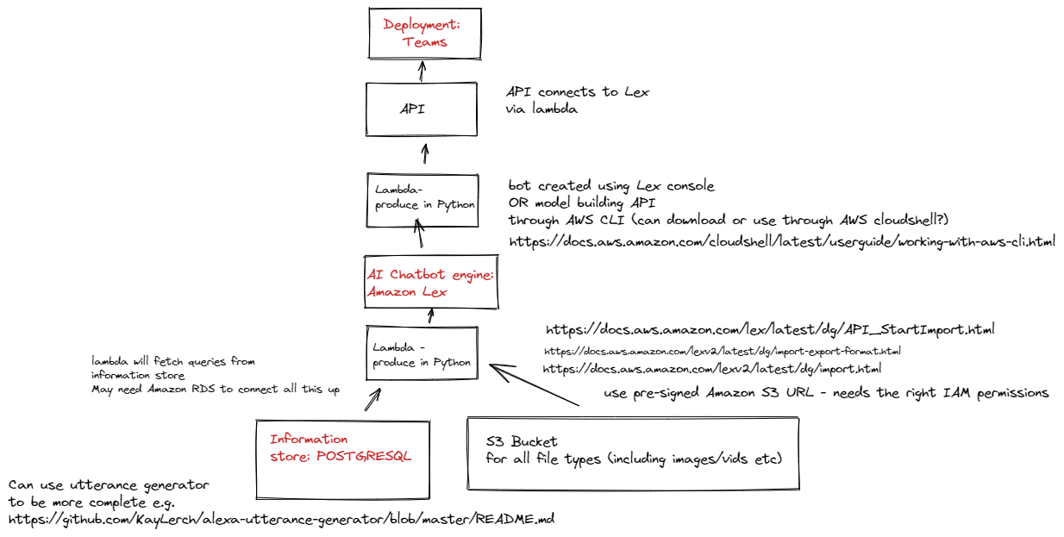

## Creating new intents and utterances

### CSV

Update the CSV in this folder *“intents_utterances.csv”* with a new intent, copy the existing structure for previous intents.

Important:

* Intent names must be unique
* Intents should have as little crossover with existing Intents as possible e.g., Library opening times is too like Library closing times.
* When creating utterances for the intent give at least 5 examples, use varying structure and slang.

### NoSQL database

**Why?** So why use a database when Amazon Lex can store the intents etc. for us. Well there are a few benefits, a database is easier for version control and general transparency and audit measures as well as being able to rollback. Secondly most people are already familiar with a database structure and so don’t require to train people in AWS to add new intents. Additionally the team won’t need AWS credentials and access making it more widely accessible to DACT. General maintenance will be quicker as we can just find and replace in the CSV as opposed to going into each intent individually to fix a spelling mistake in AWS.

The input for Amazon Lex (the chatbot software in AWS) needs to be **JSON** format. A **NoSQL** databased can store this semi-structured data.

The python code *“csv_2_json.py”* ingests the *“intents_utterances.csv”* and converts the CSV into JSON format.

Using Amazon IAM create a new user and then copy credentials from “jen_programmatic_access” then write down your key and secret – save it in *“AWS_keys.py”* but do not upload to Github.

Running the code *“dynamodb.py”* adds the JSON file to a **DynamoDB** table format.

You can see the table create in AWS DynamoDB <https://us-east-1.console.aws.amazon.com/dynamodbv2/home?region=us-east-1#tables> you need to make sure you are in the US-east-1 location.

Note: To manually export/import intents from Amazon Lex follow the instructions here <https://docs.aws.amazon.com/lex/latest/dg/export-to-lex.html>

### Testing

Now log in to AWS and navigate to **Amazon Lex** and build the chatbot. [https://us-east-1.console.aws.amazon.com/lexv2/home?region=us-east-1#](https://us-east-1.console.aws.amazon.com/lexv2/home?region=us-east-1)

We need to test we have enough utterances in other words that the chatbot works. For the new intent type in a question that is not an existing utterance. Check that the bot “ALEX” understands, and the format of the reply is correct.

## Lambda functions

## API

## Integration with MS teams

## Resources

[What Is Amazon Lex? - Amazon Lex](https://docs.aws.amazon.com/lex/latest/dg/what-is.html)

[What is AWS Lambda? - AWS Lambda (amazon.com)](https://docs.aws.amazon.com/lambda/latest/dg/welcome.html)